Calendar Year
# Source: AI Source: Provided by: [Data Path: Persons Table -> ID Column: 1, Name_En Column: Motasem Essam] -> From: [ChatGPT] on [7/17/2026]
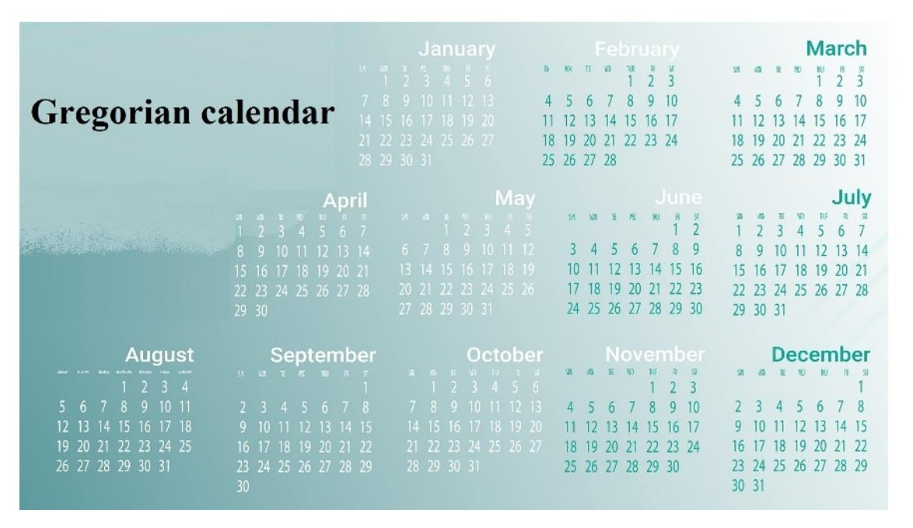
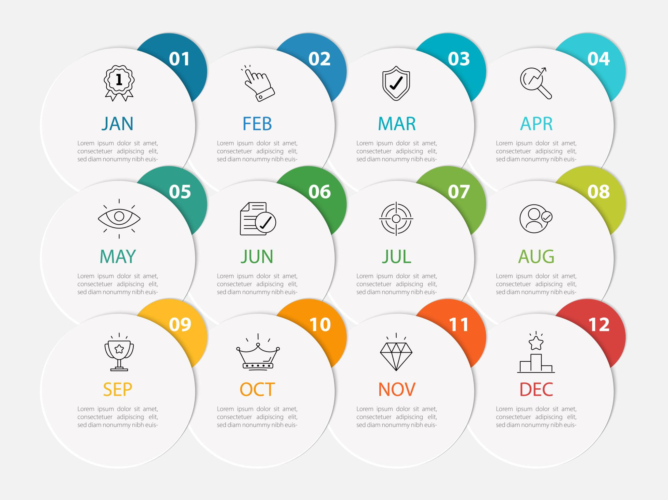
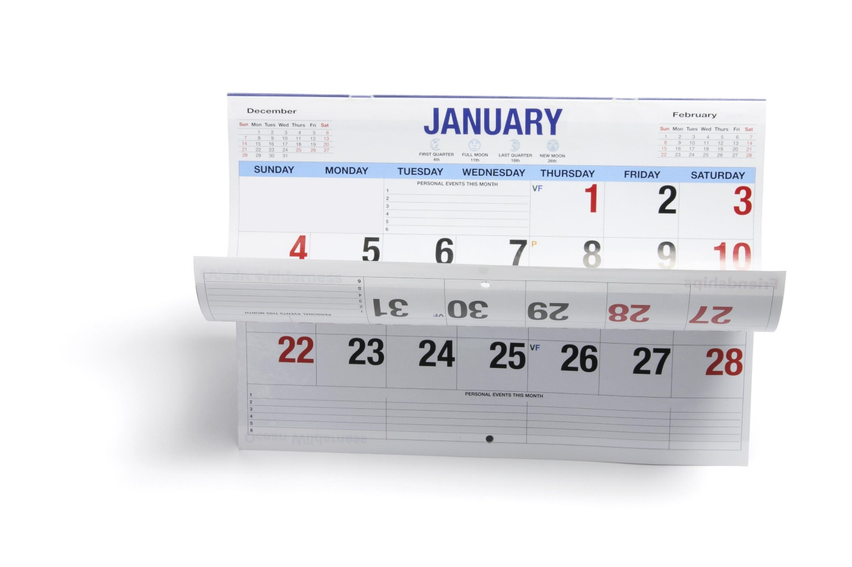
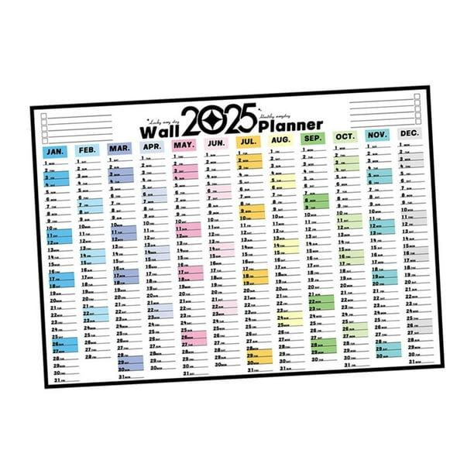
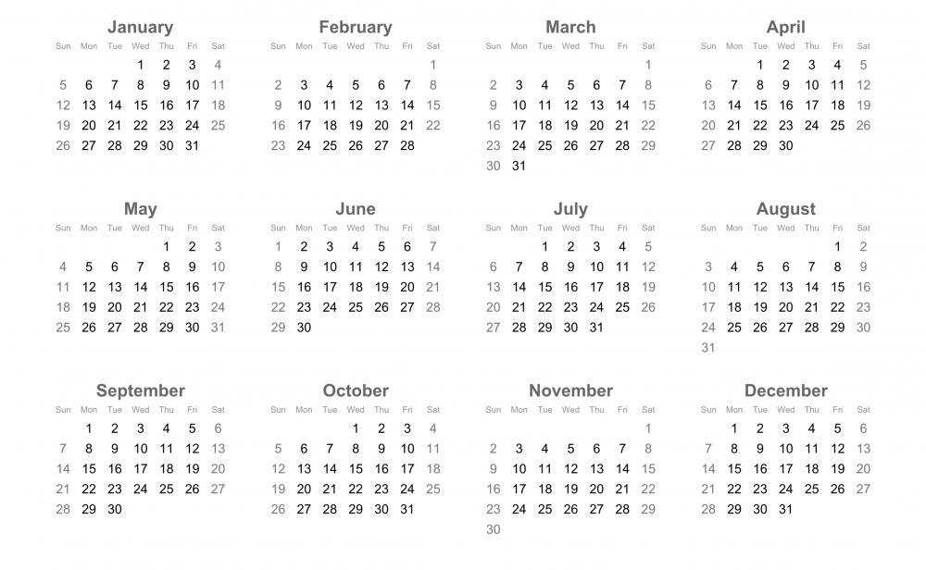
A Calendar Year is the standard civil year used in a calendar system. It is a fixed period that begins on the first day of the year and ends on the last day of the year according to the rules of that calendar.
In the Gregorian Calendar, which is the most widely used civil calendar in the world, a calendar year contains 365 days in a common year or 366 days in a leap year.

Definition
# Source: AI Source: Provided by: [Data Path: Persons Table -> ID Column: 1, Name_En Column: Motasem Essam] -> From: [ChatGPT] on [7/17/2026]
A Calendar Year is the official year defined by a calendar system, consisting of a fixed sequence of months and days used for civil, legal, business, educational, and historical purposes.

Purpose
# Source: AI Source: Provided by: [Data Path: Persons Table -> ID Column: 1, Name_En Column: Motasem Essam] -> From: [ChatGPT] on [7/17/2026]
A calendar year is used to:
- Organize civil timekeeping.
- Record historical events.
- Schedule education and business activities.
- Calculate age.
- Plan government and financial operations.
- Coordinate international communication.

Structure of a Calendar Year
# Source: AI Source: Provided by: [Data Path: Persons Table -> ID Column: 1, Name_En Column: Motasem Essam] -> From: [ChatGPT] on [7/17/2026]
In the Gregorian Calendar, a calendar year contains:
- 12 months
- 365 days (common year)
- 366 days (leap year)

Beginning and End
# Source: AI Source: Provided by: [Data Path: Persons Table -> ID Column: 1, Name_En Column: Motasem Essam] -> From: [ChatGPT] on [7/17/2026]
A Gregorian calendar year begins on:
- January 1
It ends on:
- December 31
Example:
- 2026 Calendar Year
  - Begins: January 1, 2026
  - Ends: December 31, 2026

Length of a Calendar Year
# Source: AI Source: Provided by: [Data Path: Persons Table -> ID Column: 1, Name_En Column: Motasem Essam] -> From: [ChatGPT] on [7/17/2026]
Common Year
Contains:
- 365 days
Equivalent to:
- 52 weeks + 1 day
Leap Year
Contains:
- 366 days
Equivalent to:
- 52 weeks + 2 days

Leap Year
# Source: AI Source: Provided by: [Data Path: Persons Table -> ID Column: 1, Name_En Column: Motasem Essam] -> From: [ChatGPT] on [7/17/2026]
A leap year occurs to keep the calendar synchronized with the Earth's orbit around the Sun.
Gregorian Leap-Year Rule
A year is a leap year if:
- It is divisible by 4,
except:
- Years divisible by 100 are not leap years,
unless:
- They are also divisible by 400.
Examples:
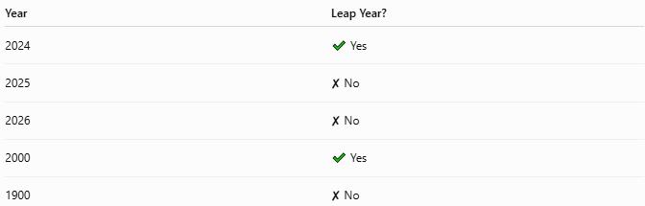
Year | Leap Year?
2024 | ✔ Yes
2025 | ✘ No
2026 | ✘ No
2000 | ✔ Yes
1900 | ✘ No

Relationship to Other Time Units
# Source: AI Source: Provided by: [Data Path: Persons Table -> ID Column: 1, Name_En Column: Motasem Essam] -> From: [ChatGPT] on [7/17/2026]
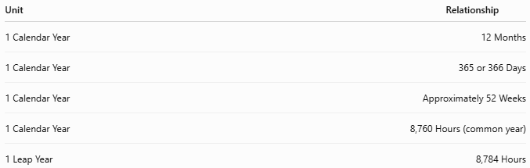
Unit | Relationship
1 Calendar Year | 12 Months
1 Calendar Year | 365 or 366 Days
1 Calendar Year | Approximately 52 Weeks
1 Calendar Year | 8,760 Hours (common year)
1 Leap Year | 8,784 Hours

Calendar Year vs. Solar Year
# Source: AI Source: Provided by: [Data Path: Persons Table -> ID Column: 1, Name_En Column: Motasem Essam] -> From: [ChatGPT] on [7/17/2026]
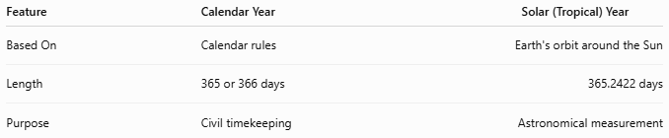
Feature | Calendar Year | Solar (Tropical) Year
Based On | Calendar rules | Earth's orbit around the Sun
Length | 365 or 366 days | 365.2422 days
Purpose | Civil timekeeping | Astronomical measurement
The leap-year system keeps the calendar year closely aligned with the solar year over long periods.

Applications
# Source: AI Source: Provided by: [Data Path: Persons Table -> ID Column: 1, Name_En Column: Motasem Essam] -> From: [ChatGPT] on [7/17/2026]
Calendar years are used in:
- Government
- Education
- Business
- Banking
- Accounting
- Taxation
- Historical records
- Scientific documentation

Advantages
# Source: AI Source: Provided by: [Data Path: Persons Table -> ID Column: 1, Name_En Column: Motasem Essam] -> From: [ChatGPT] on [7/17/2026]
Calendar years:
- Provide a consistent annual schedule.
- Standardize international dates.
- Keep civil time aligned with the seasons.
- Simplify planning and record keeping.

Limitations
# Source: AI Source: Provided by: [Data Path: Persons Table -> ID Column: 1, Name_En Column: Motasem Essam] -> From: [ChatGPT] on [7/17/2026]
Calendar years:
- Are an approximation of the true solar year.
- Require leap-year adjustments.
- Differ from year definitions in some religious or traditional calendar systems.

Common Mistakes
# Source: AI Source: Provided by: [Data Path: Persons Table -> ID Column: 1, Name_En Column: Motasem Essam] -> From: [ChatGPT] on [7/17/2026]
- Assuming every calendar year has exactly 365 days.
- Confusing a calendar year with a solar year or a lunar year.
- Forgetting leap-year rules.

Examples
# Source: AI Source: Provided by: [Data Path: Persons Table -> ID Column: 1, Name_En Column: Motasem Essam] -> From: [ChatGPT] on [7/17/2026]
Examples of calendar years:
- 2024
- 2025
- 2026
- 2030
Each represents one complete civil year in the Gregorian Calendar.

Interesting Facts
# Source: AI Source: Provided by: [Data Path: Persons Table -> ID Column: 1, Name_En Column: Motasem Essam] -> From: [ChatGPT] on [7/17/2026]
- The Gregorian Calendar was introduced in 1582 to improve the accuracy of the earlier Julian Calendar.
- Today it is the international standard for civil use in most countries.
- Leap years prevent the calendar from drifting away from the seasons.

Key Points
# Source: AI Source: Provided by: [Data Path: Persons Table -> ID Column: 1, Name_En Column: Motasem Essam] -> From: [ChatGPT] on [7/17/2026]
- A Calendar Year is the official year defined by a calendar system.
- In the Gregorian Calendar:
  - Common year = 365 days
  - Leap year = 366 days
- A calendar year contains:
  - 12 months
  - Approximately 52 weeks
- Calendar years are the standard for civil, legal, educational, and business activities.

Conclusion
# Source: AI Source: Provided by: [Data Path: Persons Table -> ID Column: 1, Name_En Column: Motasem Essam] -> From: [ChatGPT] on [7/17/2026]
A Calendar Year is the standard annual period established by a calendar system for organizing civil life. In the Gregorian Calendar, it begins on January 1, ends on December 31, and contains 365 days in a common year or 366 days in a leap year. Through the use of leap years, the calendar year remains closely synchronized with the Earth's orbit around the Sun, making it a reliable framework for government, business, education, science, and everyday timekeeping.

